**Air Cargo Planning Heuristic Analysis**

Tilak

Udacity AIND – Implementation of Planning Search

Search strategies that come under **uninformed** search have no additional information about states beyond that provided in the problem definition. All they can do is generate successors and distinguish a goal state from a non‐goal state, for example Breadth First, Depth First, Uniform Searches. **Informed** search strategy are one that uses problem‐specific knowledge beyond the definition of the problem itself, they can find solutions more efficiently than an uninformed strategy.

The following tables show the results gathered after solving the air cargo problems with both uninformed and informed based search. The goal of this analysis is to document the results obtained from each search type and find an optimal solution for each air cargo problem, that is; a search algorithm that finds the lowest path among all possible paths from start to goal.

For each set of problems, the optimal and fastest solution has been highlighted with *green* color. *Red* color indicated that the test was stopped as it wasa taking longer time to conclude the search and produce an optimal path.

Below is the Air Cargo Action Schema:

Action(Load(c, p, a),

PRECOND: At(c, a) ∧ At(p, a) ∧ Cargo(c) ∧ Plane(p) ∧ Airport(a)

EFFECT: ¬ At(c, a) ∧ In(c, p))

Action(Unload(c, p, a),

PRECOND: In(c, p) ∧ At(p, a) ∧ Cargo(c) ∧ Plane(p) ∧ Airport(a)

EFFECT: At(c, a) ∧ ¬ In(c, p))

Action(Fly(p, from, to),

PRECOND: At(p, from) ∧ Plane(p) ∧ Airport(from) ∧ Airport(to)

EFFECT: ¬ At(p, from) ∧ At(p, to))

Optimal plan for Problems 1, 2, and 3 are given below along with comparison of the performance in terms of **speed** (execution time, measured in seconds), **memory usage** (measured in search node expansions) and **optimality** (Yes, if a solution of optimal length is found; No, otherwise).

1. *Problem 1*:

Below are the initial and goal states,

Init(At(C1, SFO) ∧ At(C2, JFK)

∧ At(P1, SFO) ∧ At(P2, JFK)

∧ Cargo(C1) ∧ Cargo(C2)

∧ Plane(P1) ∧ Plane(P2)

∧ Airport(JFK) ∧ Airport(SFO))

Goal(At(C1, JFK) ∧ At(C2, SFO))

Optimal path is,

Load(C1, P1, SFO)

Load(C2, P2, JFK)

Fly(P1, SFO, JFK)

Fly(P2, JFK, SFO)

Unload(C1, P1, JFK)

Unload(C2, P2, SFO)

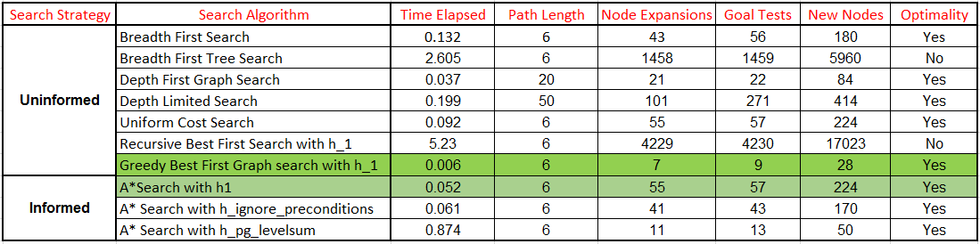

1. *Problem 2*:

Below are the initial and goal states,

Init(At(C1, SFO) ∧ At(C2, JFK) ∧ At(C3, ATL)

∧ At(P1, SFO) ∧ At(P2, JFK) ∧ At(P3, ATL)

∧ Cargo(C1) ∧ Cargo(C2) ∧ Cargo(C3)

∧ Plane(P1) ∧ Plane(P2) ∧ Plane(P3)

∧ Airport(JFK) ∧ Airport(SFO) ∧ Airport(ATL))

Goal(At(C1, JFK) ∧ At(C2, SFO) ∧ At(C3, SFO))

Optimal path is,

Load(C3, P3, ATL)

Fly(P3, ATL, SFO)

Unload(C3, P3, SFO)

Load(C1, P1, SFO)

Fly(P1, SFO, JFK)

Unload(C1, P1, JFK)

Load(C2, P2, JFK)

Fly(P2, JFK, SFO)

Unload(C2, P2, SFO)

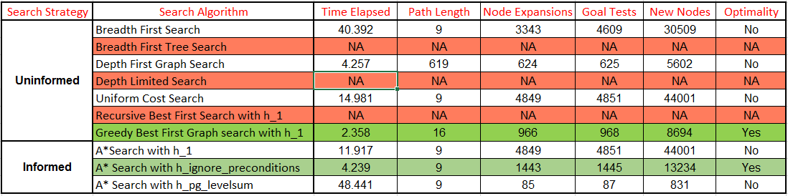

1. *Problem 3*:

Below are the initial and goal states,

Init(At(C1, SFO) ∧ At(C2, JFK) ∧ At(C3, ATL) ∧ At(C4, ORD)

∧ At(P1, SFO) ∧ At(P2, JFK)

∧ Cargo(C1) ∧ Cargo(C2) ∧ Cargo(C3) ∧ Cargo(C4)

∧ Plane(P1) ∧ Plane(P2)

∧ Airport(JFK) ∧ Airport(SFO) ∧ Airport(ATL) ∧ Airport(ORD))

Goal(At(C1, JFK) ∧ At(C3, JFK) ∧ At(C2, SFO) ∧ At(C4, SFO))

Optimal path is,

Load(C2, P2, JFK)

Fly(P2, JFK, ORD)

Load(C4, P2, ORD)

Fly(P2, ORD, SFO)

Unload(C4, P2, SFO)

Load(C1, P1, SFO)

Fly(P1, SFO, ATL)

Load(C3, P1, ATL)

Fly(P1, ATL, JFK)

Unload(C3, P1, JFK)

Unload(C2, P2, SFO)

Unload(C1, P1, JFK)

